* [Mohamedahmed01097@gmail.com](mailto:Mohamedahmed01097@gmail.com)

2023

C Pool

MAAM Subtitle

* M. A. Abdellah

# Expressions & Operators

## Mathematical Operator

1. Write a c code that will ask the user to enter a character then print it and the ASCII value of this character.
2. Write a c code that will ask the user to enter two values and print their division and reminder
3. Write a c code that will ask the user to enter two values and swap then print it
4. Write a C code that will ask the user to enter two values and swap (Without using third Variable) then print it
5. Write a C code that will ask the user to enter two values (Floating Numbers) and print their Multiply

## Bitwise Operator

1. Write a C program to input any number from user and check whether Least significant Bit (LSB) is set (1) or not (0)
2. Write a C program to input any number from user and check whether Most significant Bit (LSB) is set (1) or not (0)
3. Write a C program to input any number from user and check whether nth bit of the given number is set (1) or not (0)
4. Write a C program to input any number from user and set nth bit of the given number as (1) using bitwise operator
5. Write a C program to input any number from user and clear nth bit of the given number as (0) using bitwise operator
6. Write a C program to input any number from user and toggle nth bit of the given number using bitwise operator
7. Write a C program to take any number from user and Flip all bits of the given number (in binary representation ) using bitwise operators
8. Write a C program to take any two number from user and swap Values of both numbers using bitwise operator.

## Conditinal Operators

1. Write a C program to take Two numbers from user and find maximum between two numbers
2. Write a C program to take three numbers from user and find maximum between three numbers
3. Write C program to check even or odd number
4. Write C program to take a year from user then check whether year Is leap year or not
5. Write C program to take a character from user then check whether Character alphabets or not

# if Condition

1. Write C program to take a character from user then check whether Character Vowel or consonant.

Hint: the vowel character is (a , e, o , I, u)

1. Write a C code that will ask the user to enter number and check this number positive or negative.
2. Write a c code that will ask the user to enter four values a, b, c and d then evaluates the ratio of (a + b) to (c-d) and prints the result, if (c-d) is not equal zero.
3. Write C code to compute the real roots of the equation: ax2+bx+c=0.

The program will prompt the user to input the values of a, b, and c. It then computes the real roots of the equation based on the following rules:

* if a and b are zero=> no solution
* if a is zero=>one root (-c/b)
* if 2b-4ac is negative=>no roots
* Otherwise=> two roots The roots can be computed using the following formula: Used <math.h>

$$x1=\frac{-b+\sqrt{\left(2b-4ac\right)}}{2a} x2=\frac{-b-\sqrt{\left(2b-4ac\right)}}{2a}$$

1. Write a C program to find the eligibility of admission for a professional course based on the following criteria:

Marks in Math >=65 Marks in Physics >=55 Marks in Chemic >=50 Total in all three subject >=180

1. Write a C program to input amount from user and print minimum number of notes (Rs. 500, 200, 100, 50, 20, 10, 5, 2, 1) required for the amount.
2. Write a C program to check whether a triangle is valid or not and define the type of the triangle is equilateral, scalene or isosceles triangle, and Right, Obtuse, or Acute triangle.
3. write C Program to An electric power distribution company charges its domestic consumers as follows: Consumption Units Rate of Charge

000 – 200 Rs. 0.50 per unit

1. – 400 Rs. 100 plus Rs.0.65 per unit excess of 200

401 – 600 Rs. 230 plus Rs.0.80 per unit excess of 400

601 and above Rs. 390 plus Rs.1.00 per unit excess of 600

1. Write a C program to input electricity unit charge and calculate the total electricity bill according to the given condition:

For first 50 units Rs. 0.50/unit

For next 100 units Rs. 0.75/unit

For next 100 units Rs. 1.20/unit

For unit above 250 Rs. 1.50/unit An additional surcharge of 20% is added to the bill.

1. Write a C program to input basic salary of an employee and calculate gross salary according to given conditions.

Basic Salary <= 10000 : HRA = 20%, DA = 80%

Basic Salary is between 10001 to 20000 : HRA = 25%, DA = 90%

Basic Salary >= 20001 : HRA = 30%, DA = 95%

# Switch Cases

1. Write a C program to input week number(1-7) and print day of week name
2. Write a C program to find number of days in month. Hint:

January, March, May, July, August, October, December 31 days

February28/29 days

April, June, September, November 30 days

1. Write a C program to take two numbers from user and find maximum between two numbers using switch case
2. Write a C program to find all roots of a Quadratic equation using switch case. It then computes the real roots of the equation based on the following rules:

* if a and b are zero=> no solution
* if a is zero=>one root (-c/b)
* if 2b-4ac is negative=>two imaginary roots
* Otherwise=> two roots The roots can be computed using the following formula: Used <math.h>

$$x1=\frac{-b+\sqrt{\left(2b-4ac\right)}}{2a} x2=\frac{-b-\sqrt{\left(2b-4ac\right)}}{2a}$$

1. write C Program to Make a Simple Calculator Using switch...case

# Loops

## Basic

### For Loop

1. write a program in C to display the first 10 natural numbers.
2. write a C program to find the sum and average of first 10 natural numbers.
3. Write a program in C to display the multiplication table of a given integer.
4. Write C Program to Find LCM “Least Common Multiple” of two Numbers.

a x b = LCM(a, b) * GCD (a, b) ==> LCM(a, b) = (a x b) / GCD(a, b)

1. write C program using a cast to evaluate the equation
$$sum= \sum_{i=1}^{n}{\frac{1}{i}}$$

2. write c program to display the Fibonacci sequence of first n numbers (entered by the user) using loop.
3. Write C Program to Display Factors of a Number
4. Write C program to evaluate the power series.

𝑒𝑥=1+𝑥1!+𝑥22!+𝑥33!+⋯ 0 < x < 1 Hint: ex = T0 + T1 + T2 + ...... + Tn= sum. Tn > 0.000001

### While Loop

1. Write a C program to print all natural numbers in reverse from n to 1.
2. Write a C program to print all even numbers from 1 to n
3. Write a C program to input a number and find sum of first and last digit of the number.
4. Write a C program to input a number and find sum of digits of the number.
5. Write a C program to input a number from user and print it into words.
6. Write a C program that takes input and prints if this number is prime or not.
7. Write a C program that takes input from user and prints the reverse from this number
8. Write a C program that takes number from user and check this number is palindrome number or not

Hint: The palindrome number is the number that you read from lift to right the same from right to lift

1. write C Program to Count Number of Digits in an Integer

### Do While Loop

1. This program will read an integer number and check whether the entered number is Positive, Negative or Zero until user does want to exit.
2. write C Program to print multiplication table from 1*1 to 10*12.
3. write C Program to add numbers until user enters Zero.

## Pattern

1. Write C program to print Floyd's triangle.

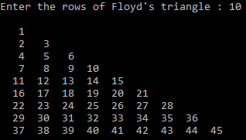

1. Write a C program to print hollow square or rectangle pattern series using for loop.

1. Write a C program to print hollow square star pattern with diagonal using loops

1. C program to print rhombus or parallelogram star pattern solid

1. C program to print hollow rhombus, parallelogram star pattern

1. C program to print hollow mirrored rhombus, parallelogram star pattern

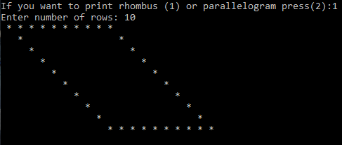

1. Write C program to print hollow inverted right triangle, hollow mirrored inverted right triangle, hollow right triangle or hollow mirrored right triangle star pattern

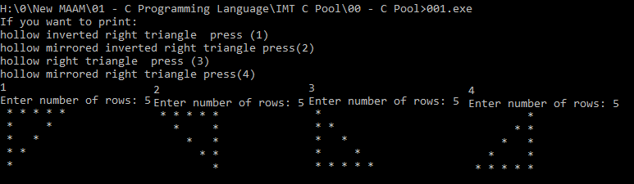

1. Write C program to print hollow pyramid (Equilateral triangle) or inverted star pattern.

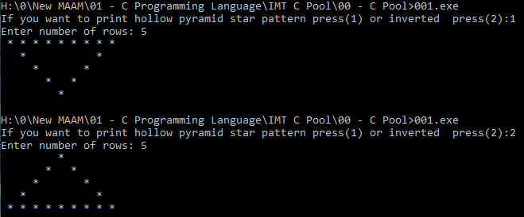

1. Write C program to print diamond, hollow diamond, half diamond or mirrored half diamond star pattern.

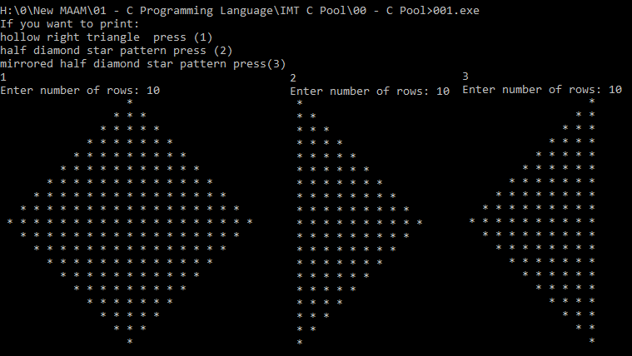

1. write C program to right, left arrow, 8 digit, heart, x symbol star pattern.

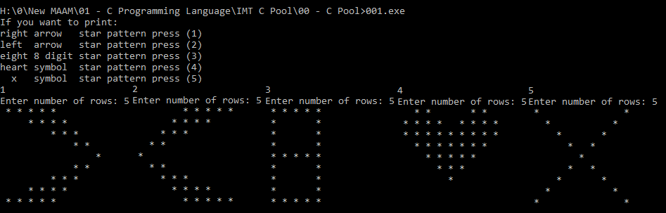

## Binary Bitwise

1. Write a C program to take any number from user and find the Total number of leading zeros in the given value
2. Write a C program to take any number from user and find the Total number of trailing zeros in the given value
3. Write a C program to take any number from user and find the Total number of in between zeros in the given value

1. Write a C program to take any number from user and find the position of the first one ‘1’
2. Write a C program to take any number from user and find the position of the last one ‘1’
3. Write a C program to take any number from user and count the total number of zeros (0s) and ones (1s)

# Functions

## Basics

1. Write C Program to input any number from user and find cube of the given number using function.
2. write C Program to find diameter, circumference and area of circle using function .
3. Write a c program to find out NCR and NPR of given number using functions.

$NCR=\frac{n!}{\left(n-r\right)!r!}$ $NPR=\frac{n!}{\left(n-r\right)! }$

1. Write C Program to calculate B(m,o) = 1, B(m,x) = B(m,x-1) [m-x+1/x ] ,x = 1,2,3,...,m Further, B(o,o) = 1
2. Write C Program to Check Whether a Number can be Expressed as Sum of Two Prime Numbers.

## Recursion

1. Write C program to find Factorial of a Number Using Recursion
2. Write a C program to input a number from user and find power of given number using recursion.
3. Write a recursive function in C programming to print all natural numbers between 1 to n.
4. Write a recursive function in C programming to print all even or odd numbers between 1 to n.
5. Write a recursive function in C programming to find reverse of a number.
6. Write a recursive function in C programming to calculate sum of digits of a number.

## Number System

1. Write a C program to take any number from user and convert it to binary number using bitwise operator
2. Write a C program to take any number from user and convert it to Hex number using bitwise operator
3. Write a C program to take any number from user and convert it to Octal number using bitwise operator
4. write C Program to convert binary number to decimal
5. write C Program to convert Hex number to decimal
6. write C Program to convert Octal number to decimal
7. Write C Program to Convert Number System From To.
8. Write a C program to take any number from user and rotate bits in circle to right and to left of number using bitwise operators.

## STD Functions

1. Write C program to get rounding of the Number.
2. Write C Program to Check Armstrong Number.
3. Write C Program to Check Prime Number.
4. Write C Program to Check Perfect Number.
5. Write a function to generate nth Fibonacci term in C programming.

|  |  |
| --- | --- |
| Armstrong | Prime |
|  | Prime number - Wikipedia |
| Perfect | Fibonacci |
| Is 28 a perfect number? What is one more example of a perfect number? -  Quora |  |

1. Write C Program to find square root to integer number.
2. Write C program to find root of integer number by using functions.
3. Write function to find power of float number , positive or negative power.
4. Write C program to find float modulate.
5. Write C program to find nth logarithm of x. $\ln\left(x\right)=2\left(\left(\frac{x-1}{x+1}\right)+\frac{1}{3}{\left(\frac{x-1}{x+1}\right)}^{3}+\frac{1}{5}{\left(\frac{x-1}{x+1}\right)}^{5}+…\right), \log_{a}{(Y)}=\frac{\ln\left(Y\right)}{ln⁡(a)}$
6. Write C program to find sin, cos, tan. $Sin\left(x\right)=\frac{x}{1!}-\frac{x^{3}}{3!}+\frac{x^{5}}{5!}-\frac{x^{7}}{7!}…, Cos\left(x\right)= 1- \frac{x^{2}}{2!}+\frac{x^{4}}{4!}-\frac{x^{6}}{6!}+…$

# Array & Matrices & Strings

## Array

1. Write a C program to find all negative elements in an array.
2. Write a C program to declare, initialize, input elements in array and print array.
3. Write a C program to read elements in an array and find the sum of array elements.
4. Write a C program to find largest and second largest element in an array.
5. Write a C program to input elements in array from user and count even and odd elements in array.
6. Write a C program to input elements in array and put even and odd elements in separate array
7. Write a C program to insert element in array at specified position.
8. Write C program to delete an element in an array: This program delete or removes an element from an array. User will enter the position at which array element is to be deleted. Deleting an element does not affect the size of the array. It is also checked whether deletion is possible or not, for example, if array contains five elements and user wants to delete element at sixth position, it is not possible.
9. Write C program to merge two arrays into third array: Arrays are assumed to be sorted in ascending order. You enter two short sorted arrays and combine them to get a large array
10. Write a program to read an age of 15 person you entered by yourself during run time of the code & find out how many of them fall under :

a) Still a baby-age 0 to 5

b) Attending school -age 6 to 17

c) Adult life-age 18 & over

1. Write C Program to Print the Alternate Elements in an Array.
2. Write a C program to left rotate an array by n position
3. Write a C program to right rotate an array by n position.

## Matrix

1. Write C Program to Add Two Matrix Using Multi-dimensional Arrays
2. Write C Program to Multiply Two Matrices his program takes two matrices of order r1*c1 and r2*c2 respectively.

To multiply two matrices, the number of columns of first matrix should be equal to the number of rows to second matrix. This program displays the error until the number of columns of first matrix is equal to the number of rows of second matrix.

1. Write C Program to Find Transpose of a Matrix In this program, user is asked to entered the number of d to enter elements of the matrix (of order r*c). Rows r and columns c. The value of r and should be less than 10 in this program. The user is asked to enter elements of the matrix (of order r*c).
2. Write C program to print This output.



## String

1. Write c program to Find the Frequency of Characters

Hint : This program asks user to enter a string and a character and checks how many times the character is repeated in the string()

1. This program counts the number of vowels, consonants, digits and white-spaces in a string which is entered by the user
2. Write C Program to Remove spaces or excess blanks from a string,
3. Write C Program to Find the Length of a String
4. Write C Program to Copy String Without Using strcpy()
5. Write C Program to compare two strings.
6. Write C program to swap two Strings.
7. Write C program to reverse a String.

# Pointers

1. write C program to print array after removing duplicates using pointers.
2. Write C Program to Find 2 Elements in the Array such that Difference between them is Largest using pointers
3. Write C program to print the number that is repeated and print times of repeated
4. Write C program to do cycle swapping.
5. Write C Program to Sort Elements in Lexicographical Order (Dictionary Order)
6. Write C program to print heart star pattern with name in center

# Structures, Unions and Enums

1. Write C Program to add two distances in inch-feet system

int feet; float inch;

1. This program takes two complex numbers as structures and adds them with the use of functions.
2. Write c program to Calculate Difference Between Two Time Periods by using structure
3. Write a C Program to Return multiple value from function -using structure.
4. Write C Program to create enumerated data type for 12 months display their values in integer constants.

|  |
| --- |
| #define SET_BIT(reg, bit) reg |= (1U<<bit)  #define CLR_BIT(reg, bit) reg &= ~(1U<<bit)  #define TOG_BIT(reg, bit) reg ^= (1U<<bit)  #define GET_BIT(reg, bit) (reg>>bit) & 1U |
| #define SET_REG(reg) reg |= ~0U  #define CLR_REG(reg) reg &= ~0U  #define TOG_REG(reg) reg ^= ~0U |
| #define MIN(a, b) ((a)<(b)?(a):(b))  #define MIN(a, b) ((a)<(b)?(a):(b)) |
| #define INT_MAX 0x7FFFFFFF  #define INT_MIN 0x80000000 |

Repeated Mistakes :

1. Scanf() with uint8_t, uint16_t 😊
2. Miss & Operator at scanf()
3. Miss Return of function.
4. Type Casting.
5. String Element.
6. update before write “don't move after open the gate”.
7. swap function with ref without real variable.
8. check the NULL pointer of the function parameter.
9. Size of the local array can be not constant.

Contents

1) Expressions & Operators 1

a) Mathematical Operator 1

b) Bitwise Operator 1

c) Conditinal Operators 1

2) if Condition 1

3) Switch Cases 2

4) Loops 2

a) Basic 2

i) For Loop 2

ii) While Loop 3

iii) Do While Loop 3

b) Pattern 3

c) Binary Bitwise 6

5) Functions 6

a) Basics 6

b) Recursion 6

c) Number System 7

d) STD Functions 7

6) Array & Matrices & Strings 8

a) Array 8

b) Matrix 8

c) String 9

7) Pointers 9

8) Structures, Unions and Enums 9

9) Systems 9